# 9. CUTOVER STRATEGY AND TRANSITION PLAN

## 9.1 Definition

Cutover strategy is a set of **migration steps** that would be applied in **implementing a new system** and **replace the existing system** in the process. The cutover strategy is also referred as implantation strategy for this reason. While there are multiple types of cutover strategies available, it must include these basic steps, which are to:

1. Design and perform **final system test** and **user acceptance tests**
2. **Transfer system control** to the users of the implemented system

Thus far, there are 4 types of cutover strategies available, in which they are named **Direct Cutover**, **Parallel Operation**, **Pilot Operation**, and **Phased Operation** respectively

## 9.2 Types of Cutover Strategy

**Direct Cutover**

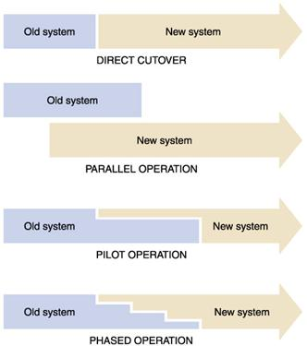

***FIGURE 9.2.1: Direct Cutover Outline***

Direct cutover strategy is a type of cutover strategy that **immediately replaces the old system with the new system** in a simultaneous order, as shown in ***FIGURE 9.2.1***. The old system would be shut down entirely so there would be no transition period where both systems are active.

While it is **less costly** for the system to be implemented, it has a **high-level risk** of the newly implemented system being entirely unusable to the client. The new system users would face many challenges to get used to the newly implemented system as well.

**Parallel Operation**



***FIGURE 9.2.2: Parallel Operation Outline***

In parallel operation strategy, the **new system is implemented while the old system is still available to use**. After a designated duration of time, the old system would be removed entirely, and the new system takes precedence as shown in ***FIGURE 9.2.2***.

Parallel operation is a strategy that could be adapted with **low risk** and **safe approach**, and thus is usually recommended to critical applications. The downside, however, being having two systems run simultaneously for a period of time and led to **high cost** of operation.

**Pilot Operation**



***FIGURE 9.2.3: Pilot Operation Outline***

Pilot operation is a system where **only part of the new system is implemented into the old system** as a means to measure its impact and effectiveness. Once the ‘pilot’ performs in satisfactory level, the replacement of the old system into the new one takes place immediately, as demonstrated in ***FIGURE 9.2.3***.

While pilot operation proves as an effective strategy in **testing new system performance** without much changes to the old system, there might be **risks of system overlap** if the system is of a large scale. Therefore, this strategy is usually applicable to moderately critical systems.

**Phased Operation**



Phased operation is a strategy where the **new system is slowly phased into the operational system**, replacing the old system in regular intervals until the new system is completely implemented. The part of system added in each phase could be referred as subsystems or units.

This cutover strategy is highly recommended for any critical system implementations since it has **relatively safe and conservative approach** compared to parallel and pilot operations. The new system user could be able to gradually get used to the system controls from such operation. The problem, however, lies in the **large amount of time** **required** to implement the new system this way, and the **higher cost** compared to direct cutover approach.

## 9.3 Selected Cutover Strategy

* Justification
* Implementation
* Requirements